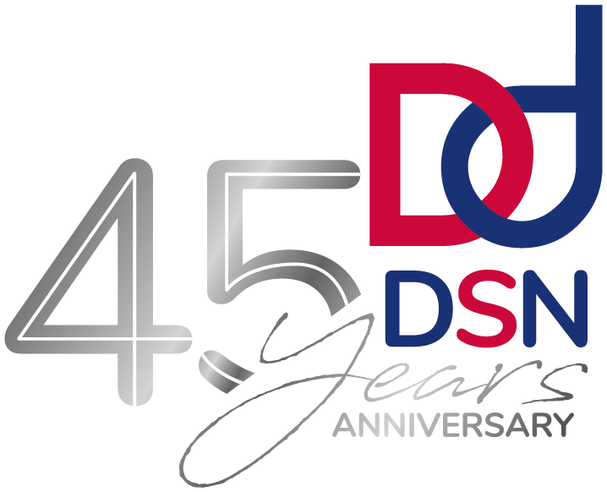
DSN ANNUAL CONFERENCE

OPEN DAY
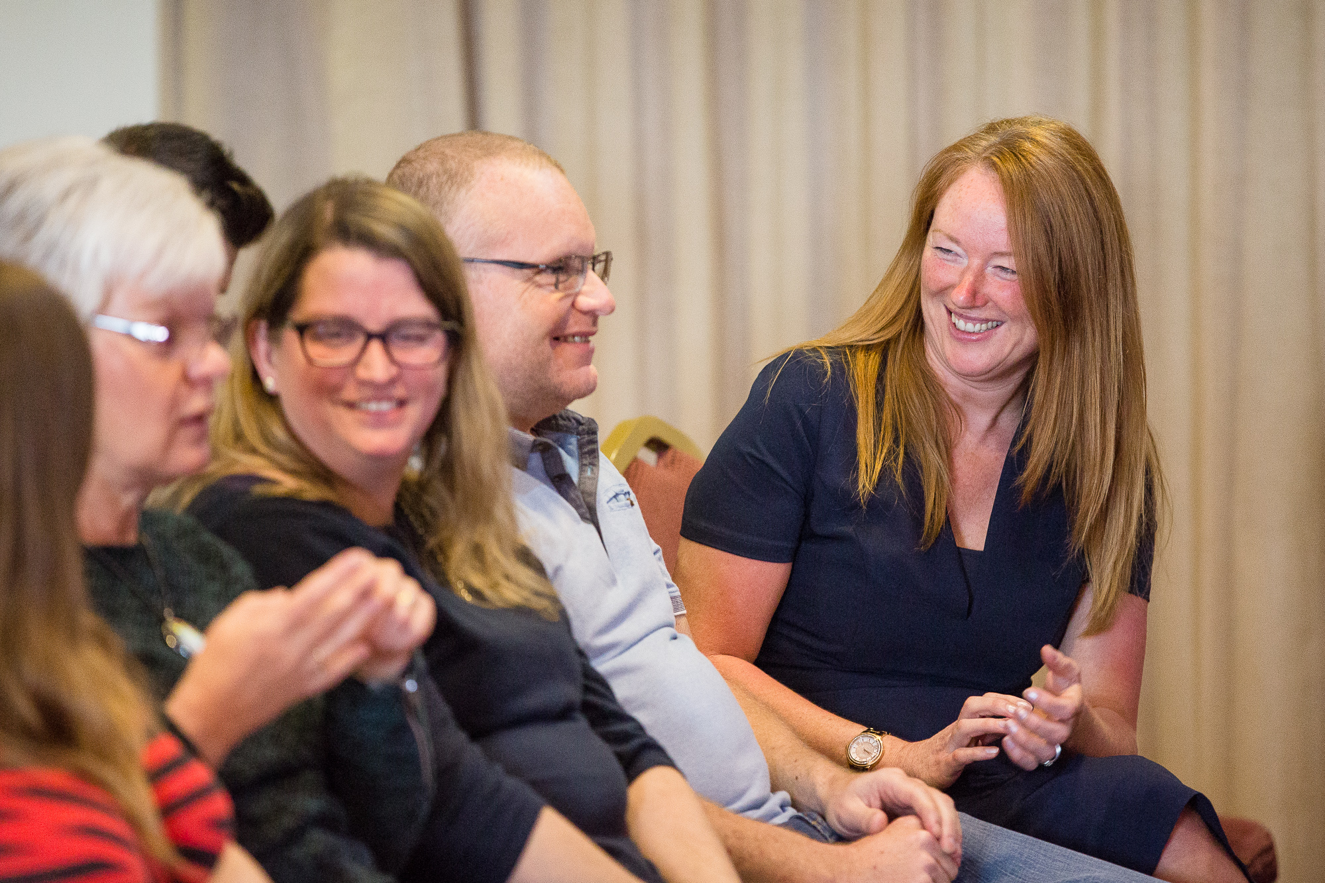

in partnership with Cheshire West & Chester Council
Unfortunately due to unforeseen circumstances and Covid restrictions, our DSN Annual Conference has been rescheduled to a new date and venue.
We look forward to welcoming you at our Open Day and celebrating 45th years of DSN.
The Open Day will showcase our services, update you on our current initiatives and strategies and will give you a chance to meet some of the team.
Communication support will be provided in the form of BSL Interpreters. If you require any alternative support, please contact us to discuss your requirements
Pop along and see us…
On: Thursday 8 July 2021, 10.00 – 4.00 pm
Monday 6 September 2021, between 1.00 – 4.00 pm

At: Crowne Plaza, Trinity Street, Chester, CH1 2BD
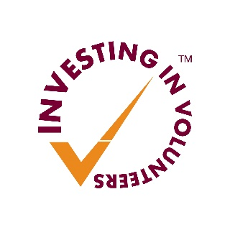
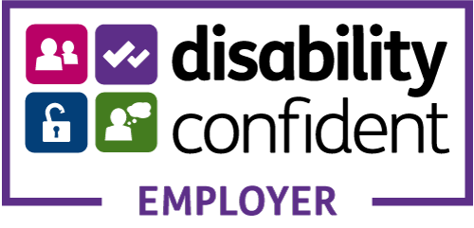
DoubleTree by Hilton Hotel & Spa, Warrington Road Hoole, Chester CH2 3PD
Deafness Support Network
144 London Road, Northwich, Cheshire, CW9 5HH
0333 220 5050 | dsn@dsnonline.co.uk | www.dsnonline.co.uk
Deafness Support Network is Registered in England & Wales as a Registered Charity No. 506791 and a Company Limited by Guarantee No. 1323762. Registered Office address 144 London Road, Northwich CW9 5HH

