Sponsorship Form

Event Name _________________

Event Date __________________

Name

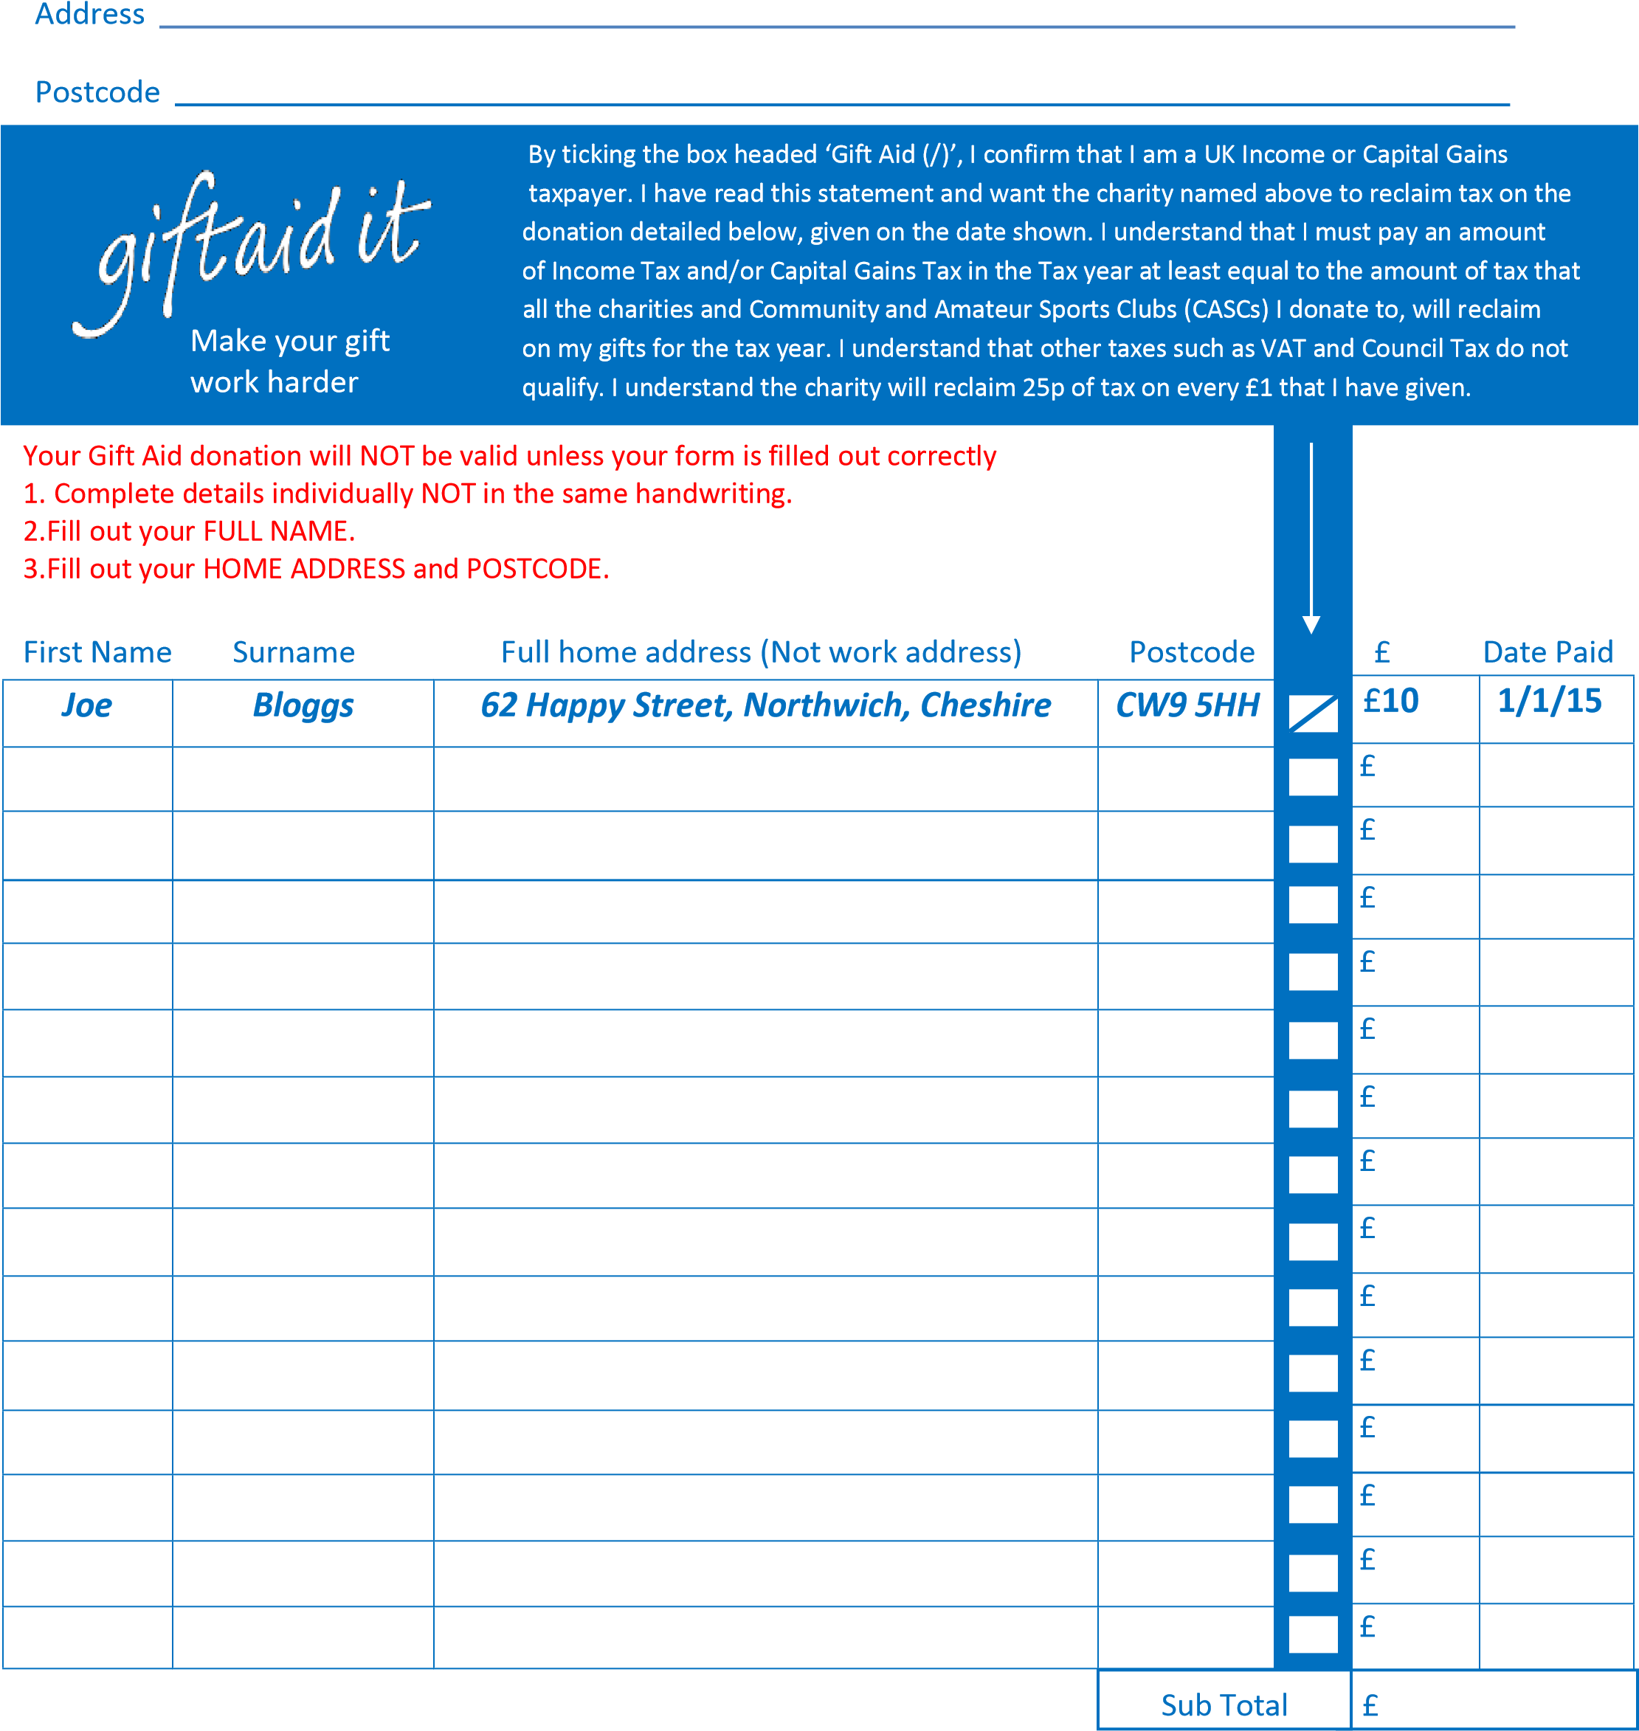
Deafness Support Network can claim Gift Aid from the Inland Revenue on all eligible donations. This is worth an extra 25p for every £1.00 you donate at no extra cost to you. The reclaimed tax arising from your charitable donations must not exceed the amount of income tax/capital gains tax payable by you for the tax year in which you make the donations.
Please tick the Gift Aid box if you wish Deafness Support Network to reclaim the tax on your donation. Reg charity no 506791. WE DO NOT USE ANY OF THE NAMES AND ADDRESSES SUPPLIED ON THIS FORM, NOR DO WE PASS THEM ON TO ANY OTHER COMPANY
